21. Write a C program for ECB, CBC, and CFB modes, the plaintext must be a sequence of one or more complete data blocks (or, for CFB mode, data segments). In other words, for these three modes, the total number of bits in the plaintext must be a positive multiple of the block (or segment) size. One common method of padding, if needed, consists of a 1 bit followed by as few zero bits, possibly none, as are necessary to complete the final block. It is considered good practice for the sender to pad every message, including messages in which the final message block is already complete. What is the motivation for including a padding block when padding is not needed?

Code:
#include <stdio.h>
#include <string.h>
#define BLOCK_SIZE 8
void printBlock(int b[], int n)
{
int i;
for (i = 0; i < n; i++)
printf("%d", b[i]);
printf("\n");
}
void encryptBlock(int in[], int out[])
{
int key[BLOCK_SIZE] = {1,0,1,0,1,0,1,0};
int i;
for (i = 0; i < BLOCK_SIZE; i++)
out[i] = in[i] ^ key[i];
}
void decryptBlock(int in[], int out[])
{
encryptBlock(in, out);
}

void padMessage(int input[], int len, int padded[], int *newLen)
{
int i;
for (i = 0; i < len; i++)
padded[i] = input[i];
padded[len] = 1;
i = len + 1;
while (i % BLOCK_SIZE != 0)
{
padded[i] = 0;
i++;
}
if (len % BLOCK_SIZE == 0)
{
int j;
padded[len] = 1;
for (j = len + 1; j < len + BLOCK_SIZE; j++)
padded[j] = 0;
i = len + BLOCK_SIZE;
}
*newLen = i;
}
void ECB(int plaintext[], int ciphertext[], int len)
{
int i;
for (i = 0; i < len; i += BLOCK_SIZE)
encryptBlock(&plaintext[i], &ciphertext[i]);
}
void CBC(int plaintext[], int ciphertext[], int len)
{
int IV[BLOCK_SIZE] = {1,0,1,0,1,0,1,0};
int temp[BLOCK_SIZE];
int previous[BLOCK_SIZE];
int i, j;
for (j = 0; j < BLOCK_SIZE; j++)
previous[j] = IV[j];
for (i = 0; i < len; i += BLOCK_SIZE)
{
for (j = 0; j < BLOCK_SIZE; j++)
temp[j] = plaintext[i+j] ^ previous[j];
encryptBlock(temp, &ciphertext[i]);
for (j = 0; j < BLOCK_SIZE; j++)
previous[j] = ciphertext[i+j];
}
}
void CFB(int plaintext[], int ciphertext[], int len)
{
int IV[BLOCK_SIZE] = {1,0,1,0,1,0,1,0};
int feedback[BLOCK_SIZE];
int encryptedIV[BLOCK_SIZE];
int i, j;
for (j = 0; j < BLOCK_SIZE; j++)
feedback[j] = IV[j];
for (i = 0; i < len; i += BLOCK_SIZE)
{
encryptBlock(feedback, encryptedIV);
for (j = 0; j < BLOCK_SIZE; j++)
ciphertext[i+j] = plaintext[i+j] ^ encryptedIV[j];
for (j = 0; j < BLOCK_SIZE; j++)
feedback[j] = ciphertext[i+j];
}
}
int main()
{
int plaintext[] = {
0,0,0,1,0,0,1,0,
1,1,0,0,1,0,1,1
};
int len = sizeof(plaintext) / sizeof(plaintext[0]);
int padded[100];
int newLen;
int ecb[100];
int cbc[100];
int cfb[100];
int i;
padMessage(plaintext, len, padded, &newLen);
printf("Original Plaintext: ");
printBlock(plaintext, len);
printf("Padded Plaintext: ");
for (i = 0; i < newLen; i++)
printf("%d", padded[i]);
printf("\n\n");
ECB(padded, ecb, newLen);
printf("ECB Ciphertext: ");
for (i = 0; i < newLen; i++)
printf("%d", ecb[i]);
printf("\n");
CBC(padded, cbc, newLen);
printf("CBC Ciphertext: ");
for (i = 0; i < newLen; i++)
printf("%d", cbc[i]);
printf("\n");
CFB(padded, cfb, newLen);
printf("CFB Ciphertext: ");
for (i = 0; i < newLen; i++)
printf("%d", cfb[i]);
printf("\n");
return 0;
}
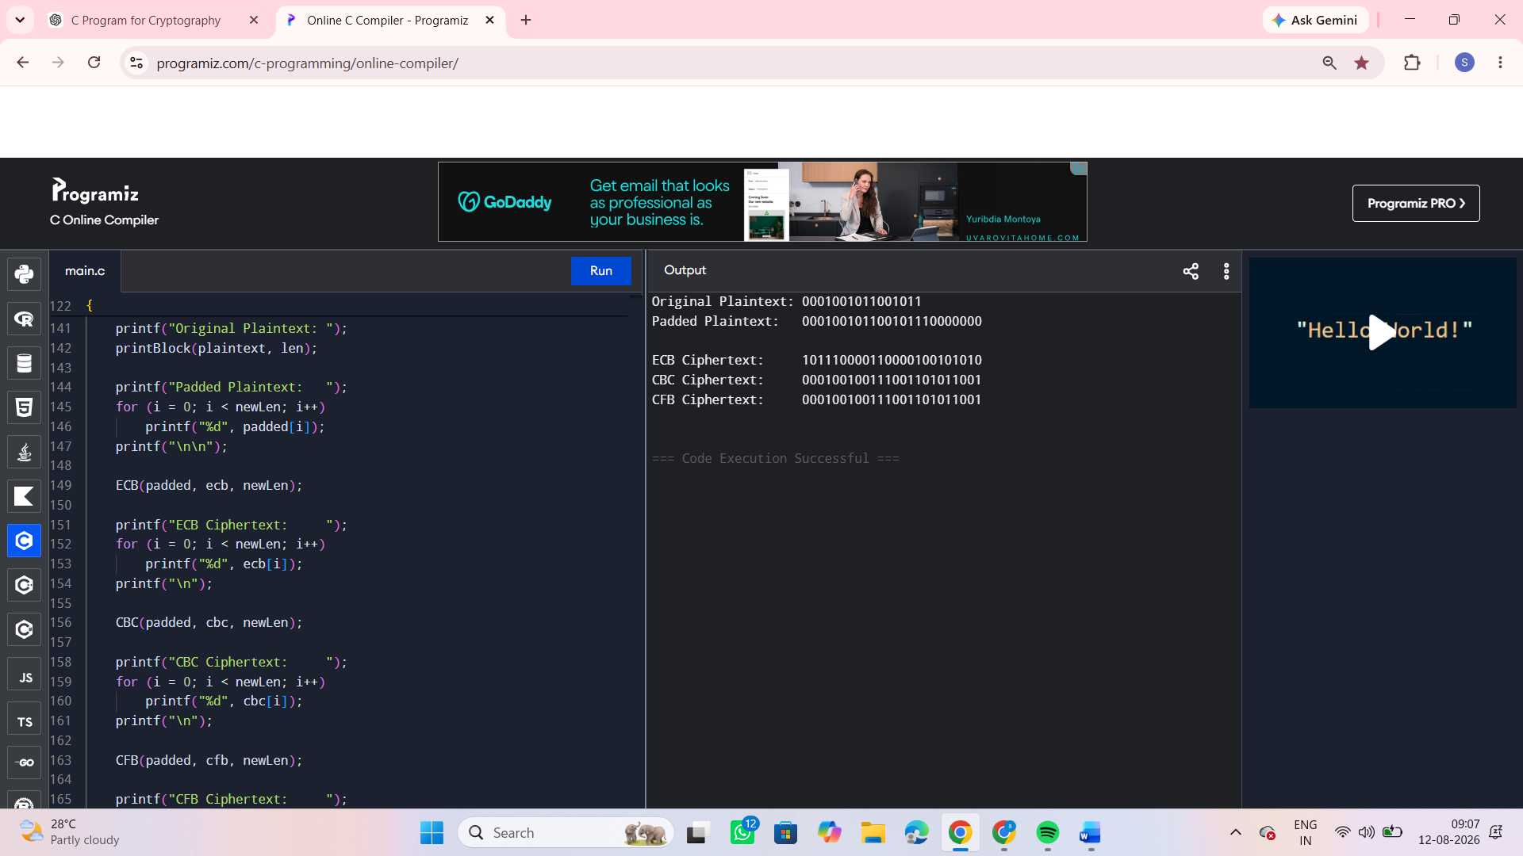

22. Write a C program for Encrypt and decrypt in cipher block chaining mode using one of the following ciphers: affine modulo 256, Hill modulo 256, S-DES, DES. Test data for S-DES using a binary
initialization vector of 1010 1010. A binary plaintext of 0000 0001 0010 0011 encrypted with a binary
key of 01111 11101 should give a binary plaintext of 1111 0100 0000 1011. Decryption should work
correspondingly.
Code:
#include <stdio.h>

int P10[] = {3,5,2,7,4,10,1,9,8,6};
int P8[] = {6,3,7,4,8,5,10,9};
int IP[] = {2,6,3,1,4,8,5,7};
int IP_INV[]= {4,1,3,5,7,2,8,6};
int EP[] = {4,1,2,3,2,3,4,1};
int P4[] = {2,4,3,1};
int S0[4][4] = {
{1,0,3,2},
{3,2,1,0},
{0,2,1,3},
{3,1,3,2}
};
int S1[4][4] = {
{0,1,2,3},
{2,0,1,3},
{3,0,1,0},
{2,1,0,3}
};
void permute(int input[], int output[], int p[], int n)
{
int i;
for (i = 0; i < n; i++)
output[i] = input[p[i] - 1];
}
void leftShift(int a[], int n, int shifts)
{
int temp[5];
int i;
while (shifts--)
{
temp[0] = a[0];
for (i = 0; i < n - 1; i++)
a[i] = a[i + 1];
a[n - 1] = temp[0];
}
}
void generateKeys(int key[], int K1[], int K2[])
{
int temp[10];
int left[5], right[5];
int i;
permute(key, temp, P10, 10);
for (i = 0; i < 5; i++)
{
left[i] = temp[i];
right[i] = temp[i + 5];
}
leftShift(left, 5, 1);
leftShift(right, 5, 1);
for (i = 0; i < 5; i++)
{
temp[i] = left[i];
temp[i + 5] = right[i];
}
permute(temp, K1, P8, 8);
leftShift(left, 5, 2);
leftShift(right, 5, 2);
for (i = 0; i < 5; i++)
{
temp[i] = left[i];
temp[i + 5] = right[i]; }
permute(temp, K2, P8, 8);}
void XOR(int a[], int b[], int result[], int n)
{
int i;
for (i = 0; i < n; i++)
result[i] = a[i] ^ b[i];
}
void fk(int input[], int key[], int output[])
{
int left[4], right[4];
int expanded[8];
int xored[8];
int sboxOutput[4];
int p4[4];
int i;
for (i = 0; i < 4; i++)
{
left[i] = input[i];
right[i] = input[i + 4];
}
permute(right, expanded, EP, 8);
XOR(expanded, key, xored, 8);
int row, col, value;
row = xored[0] * 2 + xored[3];
col = xored[1] * 2 + xored[2];
value = S0[row][col];
sboxOutput[0] = (value >> 1) & 1;
sboxOutput[1] = value & 1;

row = xored[4] * 2 + xored[7];
col = xored[5] * 2 + xored[6];
value = S1[row][col];
sboxOutput[2] = (value >> 1) & 1;
sboxOutput[3] = value & 1;
permute(sboxOutput, p4, P4, 4);
for (i = 0; i < 4; i++)
output[i] = left[i] ^ p4[i];
for (i = 0; i < 4; i++)
output[i + 4] = right[i];
}
void SDES_Encrypt(int plaintext[], int ciphertext[], int key[])
{
int K1[8], K2[8];
int temp[8], temp2[8];
generateKeys(key, K1, K2);
permute(plaintext, temp, IP, 8);
fk(temp, K1, temp2);
int i;
for (i = 0; i < 4; i++)
{
temp[i] = temp2[i + 4];
temp[i + 4] = temp2[i];
}
fk(temp, K2, temp2);
permute(temp2, ciphertext, IP_INV, 8);
}
void SDES_Decrypt(int ciphertext[], int plaintext[], int key[])
{
int K1[8], K2[8];
int temp[8], temp2[8];
generateKeys(key, K1, K2);
permute(ciphertext, temp, IP, 8);
fk(temp, K2, temp2);
int i;
for (i = 0; i < 4; i++)
{temp[i] = temp2[i + 4];
temp[i + 4] = temp2[i];}
fk(temp, K1, temp2);
permute(temp2, plaintext, IP_INV, 8);
}
void printBits(int a[], int n)
{
int i;
for (i = 0; i < n; i++)
{
printf("%d", a[i]);
if ((i + 1) % 8 == 0)
printf(" ");
}
printf("\n");
}
void CBC_Encrypt(int plaintext[], int ciphertext[],
int blocks, int key[])
{
int IV[8] = {1,0,1,0,1,0,1,0};
int previous[8];
int temp[8];
int i, j;
for (j = 0; j < 8; j++)
previous[j] = IV[j];
for (i = 0; i < blocks; i++)
{
for (j = 0; j < 8; j++)
temp[j] = plaintext[i*8+j] ^ previous[j];
SDES_Encrypt(temp, &ciphertext[i*8], key);
for (j = 0; j < 8; j++)
previous[j] = ciphertext[i*8+j];
}
}
void CBC_Decrypt(int ciphertext[], int plaintext[],
int blocks, int key[])
{
int IV[8] = {1,0,1,0,1,0,1,0};
int previous[8];
int temp[8];
int i, j;
for (j = 0; j < 8; j++)
previous[j] = IV[j];
for (i = 0; i < blocks; i++)
{
SDES_Decrypt(&ciphertext[i*8], temp, key);
for (j = 0; j < 8; j++)
{
plaintext[i*8+j] = temp[j] ^ previous[j];
previous[j] = ciphertext[i*8+j];
} }}
int main()
{
int key[10] = {
0,1,1,1,1,1,1,1,0,1};
int plaintext[16] = {
0,0,0,0,0,0,0,1,
0,0,1,0,0,0,1,1
};
int ciphertext[16];
int decrypted[16];
printf("Plaintext : ");
printBits(plaintext, 16);
CBC_Encrypt(plaintext, ciphertext, 2, key);
printf("Ciphertext: ");
printBits(ciphertext, 16);
CBC_Decrypt(ciphertext, decrypted, 2, key);
printf("Decrypted : ");
printBits(decrypted, 16);
return 0;
}
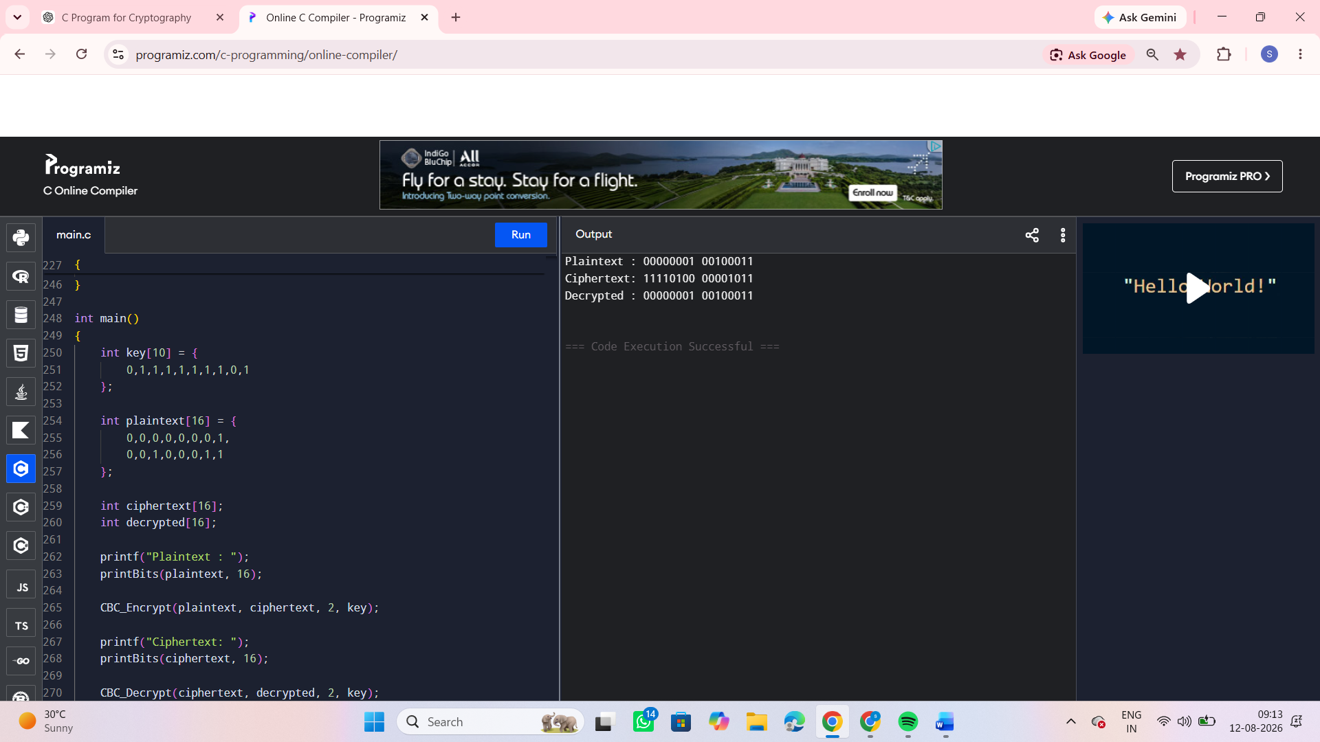

23. Write a C program for Encrypt and decrypt in counter mode using one of the following ciphers:
affine modulo 256, Hill modulo 256, S-DES. Test data for S-DES using a counter starting at 0000 0000.
A binary plaintext of 0000 0001 0000 0010 0000 0100 encrypted with a binary key of 01111 11101
should give a binary plaintext of 0011 1000 0100 1111 0011 0010. Decryption should work
correspondingly.
Code:
#include <stdio.h>
int P10[]={3,5,2,7,4,10,1,9,8,6},P8[]={6,3,7,4,8,5,10,9};
int IP[]={2,6,3,1,4,8,5,7}, IPI[]={4,1,3,5,7,2,8,6};
int EP[]={4,1,2,3,2,3,4,1},P4[]={2,4,3,1};
int S0[4][4]={{1,0,3,2},{3,2,1,0},{0,2,1,3},{3,1,3,2}};
int S1[4][4]={{0,1,2,3},{2,0,1,3},{3,0,1,0},{2,1,0,3}};
void per(int*a,int*b,int*p,int n){
for(int i=0;i<n;i++) b[i]=a[p[i]-1];
}
void sh(int*a,int n){
int t=a[0];
for(int i=0;i<n-1;i++)a[i]=a[i+1];
a[n-1]=t;
}
void keys(int*k,int*k1,int*k2){
int t[10],l[5],r[5];
per(k,t,P10,10);
for(int i=0;i<5;i++)l[i]=t[i],r[i]=t[i+5];
sh(l,5);sh(r,5);
for(int i=0;i<5;i++)t[i]=l[i],t[i+5]=r[i];
per(t,k1,P8,8);

sh(l,5);sh(l,5);sh(r,5);sh(r,5);
for(int i=0;i<5;i++)t[i]=l[i],t[i+5]=r[i];
per(t,k2,P8,8);
}
void fk(int*x,int*k,int*y){
int e[8],z[8],s[4],p[4],v,r,c;
per(x+4,e,EP,8);
for(int i=0;i<8;i++)z[i]=e[i]^k[i];
r=2*z[0]+z[3]; c=2*z[1]+z[2];
v=S0[r][c]; s[0]=v/2;s[1]=v%2;
r=2*z[4]+z[7]; c=2*z[5]+z[6];
v=S1[r][c];s[2]=v/2;s[3]=v%2;
per(s,p,P4,4);
for(int i=0;i<4;i++)y[i]=x[i]^p[i],y[i+4]=x[i+4];
}
void enc(int*x,int*y,int*k){
int k1[8],k2[8],a[8],b[8];
keys(k,k1,k2);
per(x,a,IP,8);
fk(a,k1,b);
for(int i=0;i<4;i++)a[i]=b[i+4],a[i+4]=b[i];
fk(a,k2,b);
per(b,y,IPI,8);
}
void inc(int*c){
for(int i=7;i>=0;i--)
if(c[i]==0){c[i]=1;break;}
else c[i]=0;
}

void ctr(int*p,int*c,int n,int*k){
int cnt[8]={0},e[8];
for(int b=0;b<n;b++){
enc(cnt,e,k);
for(int i=0;i<8;i++)
c[b*8+i]=p[b*8+i]^e[i];
inc(cnt);
}
}
void print(int*a,int n){
for(int i=0;i<n;i++){
printf("%d",a[i]);
if((i+1)%8==0)printf(" ");
}
printf("\n");
}
int main(){
int key[10]={0,1,1,1,1,1,1,1,0,1};
int p[24]={
0,0,0,0,0,0,0,1,
0,0,0,0,0,0,1,0,
0,0,0,0,0,1,0,0
};
int c[24],d[24];
printf("Plaintext : ");
print(p,24);
ctr(p,c,3,key);
printf("Ciphertext: ");
print(c,24);

ctr(c,d,3,key);
printf("Decrypted : ");
print(d,24);
return 0;
}
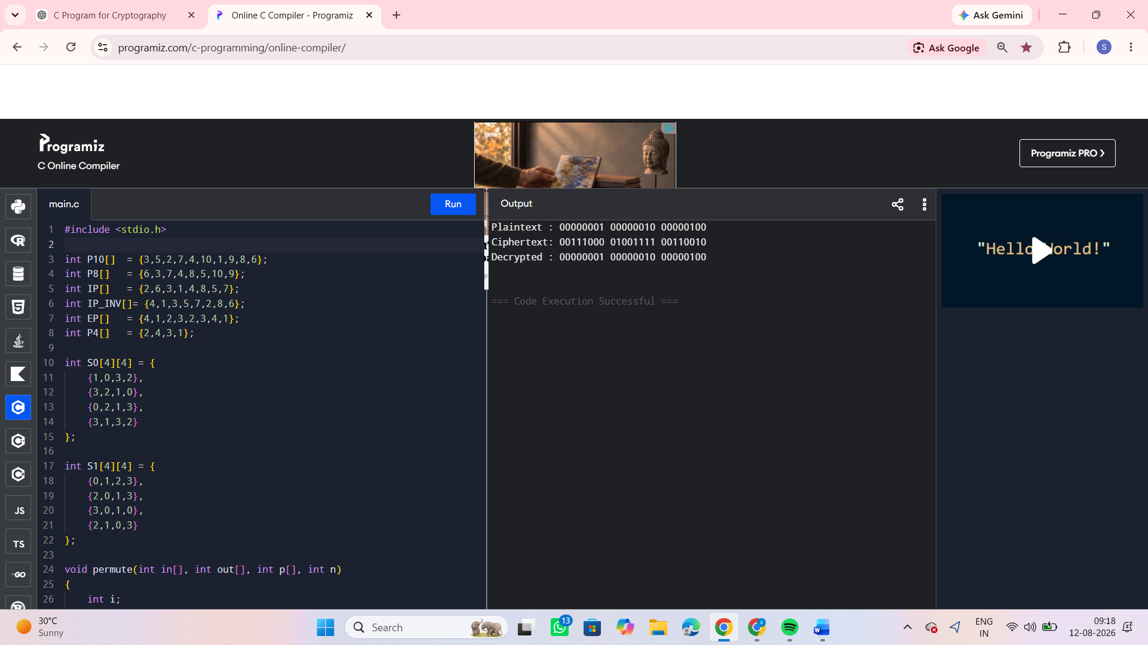

24. Write a C program for RSA system, the public key of a given user is e = 31, n = 3599. What is the
private key of this user? Hint: First use trial-and-error to determine p and q; then use the extended
Euclidean algorithm to find the multiplicative inverse of 31 modulo f(n).
Code:
#include <stdio.h>
int gcd(int a, int b)
{while (b != 0)
{ int temp = b;
b = a % b;
a = temp;}
return a;
}
int findPrivateKey(int e, int phi)
{
int d;
for (d = 1; d < phi; d++)
{
if ((e * d) % phi == 1)
return d;
}
return -1;
}
int main()
{
int e = 31;
int n = 3599;
int p = 0, q = 0;
int phi;
int d;
int i;
for (i = 2; i <= n; i++)
{ if (n % i == 0){
p = i;
q = n / i;
if (p != q)
break;} }
printf("p = %d\n", p);
printf("q = %d\n", q);
phi = (p - 1) * (q - 1);
printf("phi(n) = %d\n", phi);
if (gcd(e, phi) != 1)
{
printf("Private key does not exist.\n");
return 0;
}
d = findPrivateKey(e, phi);
printf("Public Key = (%d, %d)\n", e, n);
printf("Private Key = (%d, %d)\n", d, n);
return 0;
}
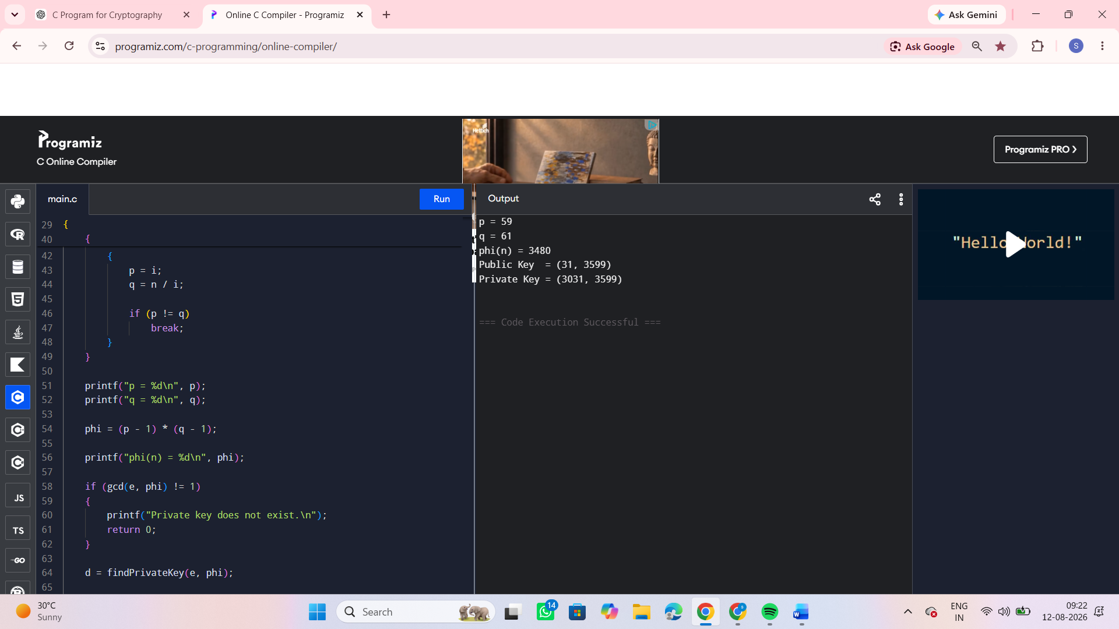
25. Write a C program for set of blocks encoded with the RSA algorithm and we don’t have the private key. Assume n = pq, e is the public key. Suppose also someone tells us they know one of the plaintext blocks has a common factor with n. Does this help us in any way?
Code:
#include <stdio.h>
int gcd(int a, int b)
{
while (b != 0)
{
int temp = b;
b = a % b;
a = temp;
}
return a;
}
int main()
{
int n;
int plaintext;
int commonFactor;
int p, q;
int phi;
printf("Enter RSA n: ");
scanf("%d", &n);
printf("Enter plaintext block: ");
scanf("%d", &plaintext);
commonFactor = gcd(plaintext, n);
printf("\nGCD(plaintext, n) = %d\n", commonFactor);
if (commonFactor == 1)
{
printf("\nNo common factor found.\n");
printf("The plaintext block does not directly reveal a factor of n.\n");
}
else if (commonFactor == n)
{
printf("\nPlaintext is a multiple of n.\n");
printf("This does not give a useful non-trivial factor.\n");
}
else
{
p = commonFactor;
q = n / p;
printf("\nA non-trivial factor of n was found!\n");
printf("p = %d\n", p);
printf("q = %d\n", q);
phi = (p - 1) * (q - 1);
printf("phi(n) = %d\n", phi);
printf("\nRSA modulus n has been factored.\n");
printf("Knowing p and q can allow recovery of the private key.\n");
}
return 0;
}
